**Whitewater Rafting Site Plan**

**Purpose**

To create an immersive and user-friendly online platform that showcases the thrill of whitewater rafting, while providing a seamless experience for customers to plan and book their adventures. The main message is that rafting is a fun activity and to come and experience it for yourself and bring your family.

Goals

• Increase Online Visibility: Establish a strong web presence to attract new customers and increase brand awareness.

• Showcase Adventures: Highlight the excitement and beauty of whitewater rafting through engaging visuals, videos, and testimonials.

• Provide Essential Information: Offer clear and concise details on trips, pricing, safety guidelines, and company policies.

• Build Community: Foster a sense of community among customers and guides through social media integration and customer reviews.

• Drive Sales: Convert website visitors into paying customers through targeted promotions, special offers, and loyalty programs.

**Target Audience**

• Demographics: Adventure-seekers, outdoor enthusiasts, and nature lovers

• Psychographics: Individuals seeking excitement, challenge, and connection with nature

• User personas: First-time rafters, experienced rafters, families, and corporate groups

**Scenarios**

The website should answer the following scenario questions:

• Information on trip levels and difficulty

• Detailed descriptions of what to expect during the trip

• Testimonials and reviews from previous customers

• Information on family-friendly trips and age restrictions

• Details on safety measures and equipment provided

• Options for booking a private guide or group trip

• Recommendations for nearby activities and attractions for non-rafters

• High-quality photos and videos showcasing the trip

• Options for customizing the trip (e.g., private guides, camping)

**Site Map**

**Branding**

Home

Contact us

About Us

Trips

Logo



**Style Guide**

Color Schema

<https://coolors.co/palette/fcb747-5698d1-f25d52-003d5b>

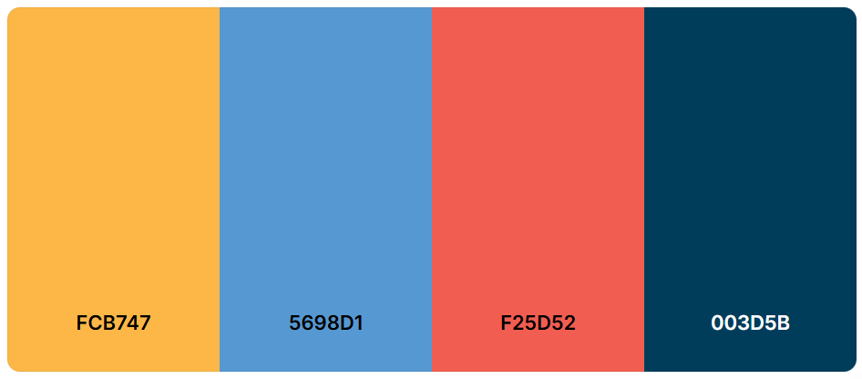j

bj

**Secondary**

**Accent 2**

**Accent 1**

**Primary**